Department of Information Systems
Bachelor of Information Systems
Lab 2
IS301 Structured Programming

Link and screenshots for the Lab1.
- Click Lab2 to view my Lab2 on GitHub.com

- Screenshot of the results.
Successful dialogue
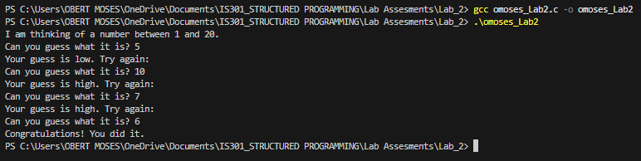
Unsuccessful dialogue
